Automated Blood Pattern Analysis: Where did all the blood come from?

In a violent crime scene, it is usually possible to find a relevant amount of bloodstains on different surfaces, such as walls, floors and other objects. These stains are a very important evidence to determine the dynamics of the events that happened on the scene, confirming or refuting someone’s statement about what occurred. The results of this analysis could help answering questions about what kind of weapon was used against the victim, where the victim was in the moment of the attack, if someone moved the victim and so on [1]. In order to define the area of origin of the blood, e.g., the victim’s position, two geometrical information about each bloodstain are needed: their impact angle (α), the angle at which the blood droplet first touches the surface in question, and their direction angle (γ), the orientation of the droplet’s trajectory [2], as shown in figures 1 and 2.
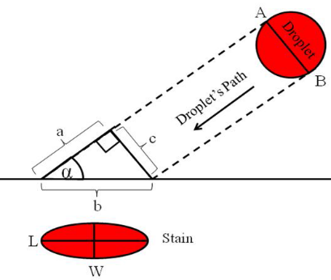 | 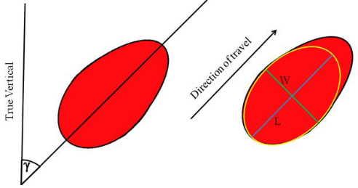
Fig. 1. Impact angle (α) at which the blood droplet first touches the surface in question. Source: [3] | Fig. 2. Direction angle (γ), the orientation of the droplet’s trajectory. Source: [3]

As one can infer from Fig. 1, if the angle α is approximately 90º, the stain would have an almost circular shape and the more α decreases, the more elliptical the stain will seem [2]. To obtain the angle γ is easy, once it can be directly measured with reference to the vertical axis, as can be seen on Fig. 2. In the other hand, the angle α ca not be directly measured and must be calculated according to the following formulation [2] where W represents the width of the elliptical bloodstain and L represents its length:
$$α=\sin^{-1}\left(\frac{W}{L}\right).$$ | (1)
The traditional approach to find the area of origin of the blood is the “string method” [1], which consists in measuring the minor and major axis of the elliptical bloodstains, attaching strings to each of them and recovering their trajectory according to the angles γ and α, that were manually measured and calculated, respectively. After this process is applied to every bloodstain, a convergence region between all strings can be found. This will be the approximate region from where the blood came. As one can imagine, the string method can take a very long time and it is also a source of imprecision, once all the measures and stringing are done manually by the crime scene experts. For that reason and considering that there is always an expressive amount of detailed pictures of a crime scene, new approaches based on digital image processing have surged. There are even some commercial softwares specialized in this analysis, for example BackTrackTM and HemoVisionTM. The procedure performed by most of these softwares is similar and consists, in general, of the following steps [4]: image rectification, image segmentation, ellipses fitting, angle calculation and 3D reconstruction. All those steps were applied in this work aiming to correctly calculate the angles involved in the blood spattering dynamics and consequently to determine the blood’s spatial origin.
In order to correctly calculate the γ and α angles, the first requisite is that the image should be taken in an orthogonal perspective with respective to the stain being analyzed. If the image used does not fulfill this requirement, the distances measured will not correspond to reality. Once the images are taken by humans, they will rarely be orthogonal. For this reason, it is necessary to perform an image rectification. This rectification was performed with a linear projective transformation using the Direct Linear Transform (DLT) algorithm [5]. The aim of the DLT algorithm is to find the homography matrix that converts the pixels of the image in perspective to the pixels in the rectified image given a set of point correspondences. It is possible to show that 4 points are sufficient to solve for the 8 degrees of freedom of the homography matrix. For that reason, it was decided, in this work, to let the user choose 4 pixels in the image to be rectified as shown in Fig. 3. In this way, the user is free to evaluate what are the best pixels to be chosen depending on the situation. Figure 4 shows the rectified image obtained from Fig. 3. The 4 chosen points formed a parallelogram in the original image, following the pattern of the folded sheet.
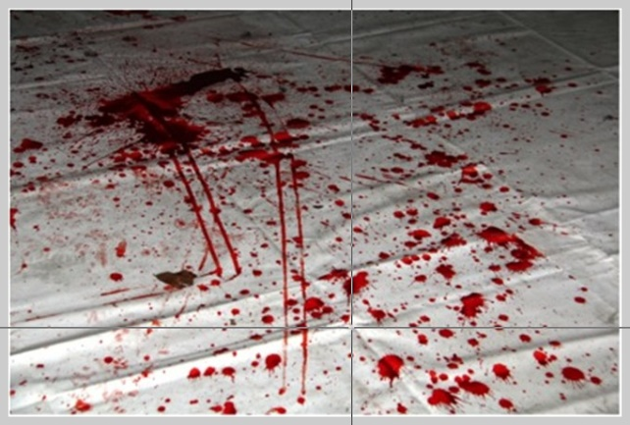 | 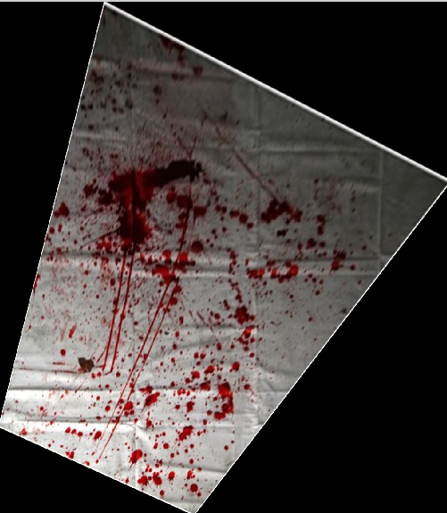
Fig. 3. The user can choose the points in the image to be rectified. | Fig. 4. Result of the rectification applied to Fig. 3. The 4 chosen points on Fig. 3 formed a parallelogram using the folding of the sheet as reference.

With the image correctly rectified, the next step was to convert the colored image to a gray level image and then to perform the global thresholding, resulting in a binary image. The thresholding was performed with Otsu’s method [6]. To guarantee a better result, a flood fill operation was applied to fill the holes inside the regions obtained with the thresholding. In this analysis, our interest relies only on the stain left by the first contact of the blood droplet with the surface. Secondary stains produced as result of the first impact should not be considering in the analysis, as they keep no direct relation with the impact angle. To remove the undesired stains, an opening operation was successfully applied with a disk as structuring element. The following step was to segment and label the regions. This was done with the Run Length Encoding algorithm [7]. To calculate the angles, it is necessary to approximate the bloodstains by ellipses. This was performed by finding the major and minor axis of each bloodstain and applying them to the generic ellipse equation. The orientation angle is obtained as the angle between the x-axis and the major axis of the ellipse that has the same second moments as the region considered. This way, it is possible to calculate the α angle by direct use of (1). The result obtained for the impact angles α of the bloodstains on Fig. 5 are shown on Fig. 6.
 | 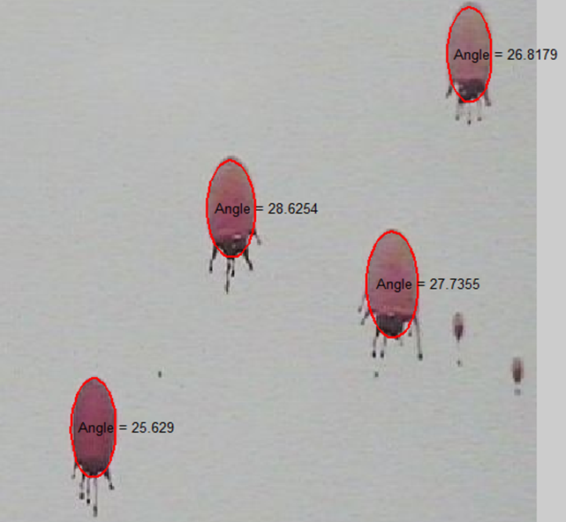
Fig. 5. Original blood spatter image. | Fig. 6. Calculated impact angles α of the bloodstains of Fig. 5.

The orientation angle γ is also available, allowing the 3D reconstruction of the room, which is done by plotting the 3D vectors that represent the trajectories of each bloodstain. The 3D vectors are defined with their origin in the droplet and leaving them with angles α and γ. With all vectors plotted in the 3D space, it is easy to find the convergence area or the victim’s position during the attack. The 3D reconstruction of the room where those bloodstains were is shown on Fig. 7. The bloodstains are marked in red and the other extremities of the vectors are in blue. The convergence area is clearly seen in the space.
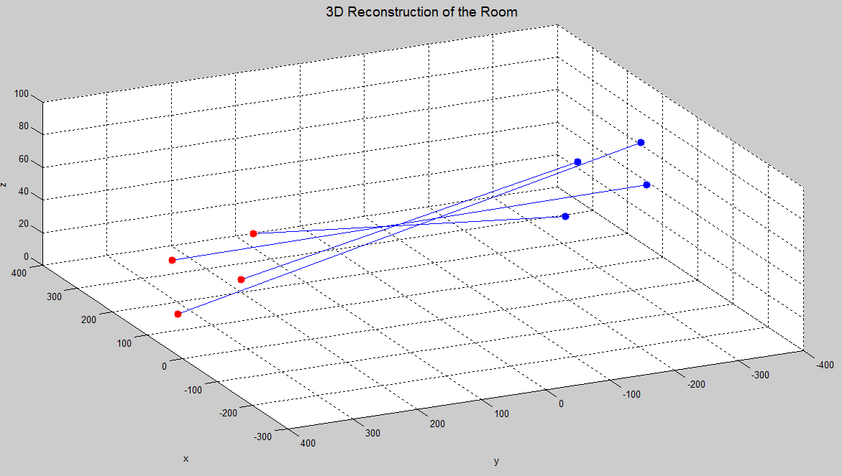
Fig. 7. 3D reconstruction of the room where the bloodstains of Fig. 5 were located. Bloodstains are marked in red.

The results obtained for the impact angles are consistent in the sense that bloodstains on the same vicinity have similar α values, as would be expected, considering that the blood came from the same region. In the same way, the results obtained for the orientation angles γ are consistent because it is possible to find a convergence area between all bloodstains when they were produced by the same event.
One possible limitation of the technique the way it is implemented on this work is the occurrence of background colors too similar to the color of the bloodstains. In this case, the segmentation process could produce incorrect results. Another possible problem is the existence of different textures on the surface receiving the blood. The fur of a carpet, for example, could distort the expected ellipsoid shape of a droplet, influencing the obtained results. Using image processing techniques to perform blood pattern analysis seems to be, if not more, as efficient as the traditional approach of the string method. This image processing approach was able to correctly calculate the angles involved in the blood spattering dynamics and consequently to determine the spatial origin of the blood. Future works would be the evaluation of the possible influence of different background colors on the technique and development of methods to improve it if necessary.
Image processing methods should also be applied to improve or even substitute other traditional methods in forensic sciences, such as footprint comparison, gunshot distance determination and so on.

REFERENCES

1. W.G. Eckert and S.H. James. Interpretation of Bloodstain Evidence at Crime Scenes. CRC Press, 2nd edition, 1999.
2. V.T. Bevel and R.M. Gardner. Bloodstain Pattern Analysis: With an Introduction to Crime Scene Reconstruction, CRC Press, 2nd edition, 2002.
3. K. Boonkhongi, M. Karnjanadecha and P. Aiyarak. “Impact angle analysis of bloodstains using a simple image processing technique,” Songklanakarin J. Sci. Technol., vol. 32, no. 2, pp. 169-173, Apr. 2010.
4. A. Shen, G. Brostow, R. Cipolla. “Toward automatic blood spatter analysis in crime scenes,” Department of Engineering, University of Cambridge.
5. R. Hartley and A. Zisserman. Multiple View Geometry in Computer Vision. Cambridge University Press, 2nd edition, 2003.
6. N. Otsu. "A threshold selection method from gray-level histograms," IEEE transactions on systems, man, and cybernetics, vol. 9, no.1, pp. 62-66, 1979.
7. S. Eddins. “Connected component labeling – Part 7”, Steve on Image Processing, MathWorks Blogs, 2007.

